World Cup 2026 Predictions and Analysis

Introduction
For the first time in World Cup history, World Cup 2026 will consist of 48 teams with 3 host countries (United States, Canada, Mexico). This report will first determine competitive matches to watch, predict the tournament bracket, followed by a post-tournament analysis.

The dataset, ‘matches_1930_2022.csv’, consists of all World Cup matches since 1930, and ‘future_match_probabilities_baseline.csv’ consists of the 2026 World Cup group stage matches. 2026 World Cup Knockout stage matches will be manually updated.

Exploratory Data Analysis
As the current system of seeding based on FIFA Rankings was only established in 2006, matches from the 2006 World Cup will be used. Countries eliminated in the Group stage, Round of 16, Quarter-Finals and Semi-Finals had an average FIFA Ranking of 31.16, 20.48, 16.65 and 11.50 respectively, with the proportion of lower-ranked countries losing increasing as the tournament progresses. This suggests that FIFA Rankings are relatively reliable in predicting how far each country goes.

However, no country ranked first made it past the Quarter-Finals, with the finalist having an average ranking of 6.80 ranked between 2 to 8, and the champions having an average ranking of 5.40. Apart from Italy in 2006, the higher-ranked nation were crowned champions. From Table 1, all champions were spearheaded by local managers, which is accurate throughout the history of the tournament. They were also not flawless in the group stages despite topping their group with a humble average goal difference of 3.2.
Year | Champions | Results | Points (GD) | Standings | Manager
2022 | Argentina | 2W, 0D, 1L | 6 (+3) | 1 | Scaloni (ARG)
2018 | France | 2W, 1D, 0L | 7 (+2) | 1 | Deschamps (FRA)
2014 | Germany | 2W, 1D, 0L | 7 (+5) | 1 | Low (GER)
2010 | Spain | 2W, 0D, 1L | 6 (+2) | 1 | Bosque (ESP)
2006 | Italy | 2W, 1D, 0L | 7 (+4) | 1 | Lippi (ITA)

Table 1: Group Stage results and Managers of previous champions

For the 2026 edition, only 6 countries within the top 10 ranked have local managers (ARG: Scaloni; ESP: de la Fuente; FRA: Deschamps; MAR: Ouahbi; NED: Koeman; GER: Nagelsmann). Since champions have historically come from countries ranked 2 to 8 led by local managers within UEFA and CONMEBOL, Spain, France and Netherlands are favourites to win this edition, with Morocco and Germany having an outside chance.

Spain are drawn in the easiest group and are expected to take 9 points from Uruguay, Saudi Arabia and Cabo Verde. However, France and Netherlands may drop points to Senegal/Norway and Japan respectively despite expecting them to top their group. As France are more likely to come against a lower ranked country in the Finals, I would expect them to win this year’s tournament.
For our model predictions, we will analyse the result of each match with respect to the lower-ranked country (‘Win’, ‘Draw’, ‘Lose’). For Knockout Stage matches, results within 90 minutes are considered. Table 2 shows the features included for this analysis.
Features | Variable Type | Descriptions
Ranking Difference | Quantitative | Based on rankings entering tournament
Round | Nominal | ‘1’ : Group stage ; ‘2’ : Round of 16  ‘3’ : Quarter-Finals; ‘4’ : Semi-Finals  ‘5’ : Finals
Home Advantage | Categorical | ‘0’ : Host country not involved  ‘1’ : Host country is higher-ranked  ‘2’ : Host country is lower-ranked

Table 2: Features and its descriptions

Since 2006, there have been 240 group stage matches, with 45% of group stage matches seeing the lower-ranked team getting at least a point from the higher-ranked team. In all 315 matches, 45.4% of them saw the lower-ranked countries cause an upset (‘Win’, ‘Draw’).

Disclaimer: Football, as we all love it, is a game of emotions and fine margins. Thus, we would expect the result of this analysis to be highly inaccurate. This analysis is purely for research and entertainment purposes and does not encourage gambling. The author takes no responsibility for any losses incurred from betting.
Competitiveness Matches of the Tournament
As the number of World Cup matches since 2006 are minimal, both training and testing set will be the same entire dataset. Logistic Regression was selected as it directly outputs class probabilities required for identifying match results, achieving an accuracy of 54.9%.

Threshold Value
Based on World Cup matches from 2006 to 2022, an average lose percentage threshold value of 48.7% is used as it results in the highest accuracy of 61.0%. Thus, a predicted percentage loss of less than 48.7% implies a potential upset for the lower-ranked country.

Historical Upsets
Upsets are defined as a country ranked at least 20 placings lower taking at least a point from the higher-ranked country. From Table 3, Korea Republic defeating Germany in Russia 2018 was the most shocking result. Germany were defending champions and were eliminated at the bottom of the group. The most recent greatest upset was Saudi Arabia defeating Argentina in Qatar 2022, breaking Argentina’s 36-match unbeaten streak dating 3 years back.
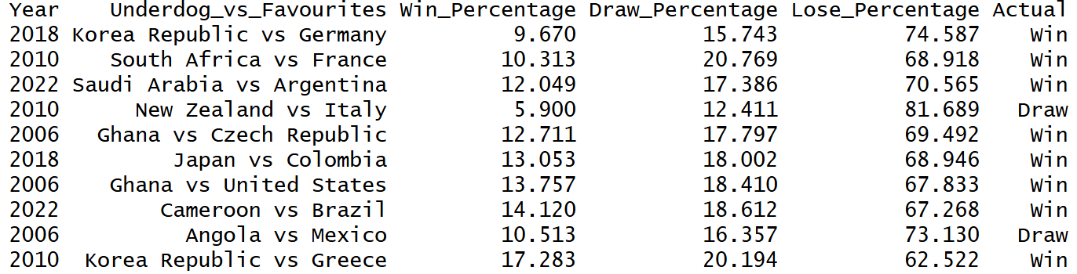
Table 3: Top 10 Upsets in World Cup History

World Cup 2026 Watchlist
The World Cup 2026 Watchlist consists of matches where the lower-ranked country has a chance to cause an upset (Table 4). Of the 72 group stage matches, we expected 17 matches to result in an upset (23.6%). This already suggests that an expanded World Cup is predicted to be less competitive. Switzerland coming up against Canada is the only match where the underdog is predicted to win the game, which is likely due to Canada’s home advantage.
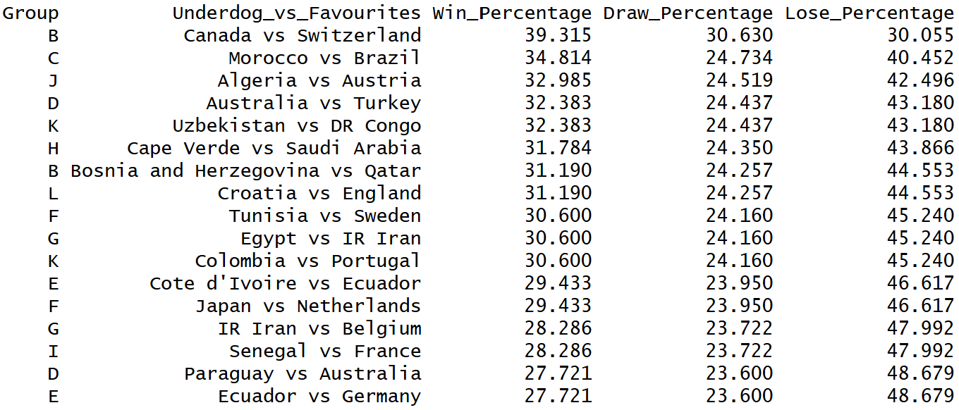
Table 4: Matches predicted to result in a potential upset
World Cup 2026 Predictions
A linear model will be used to predict the Goal Difference in each match based on all features. Since home advantage is much more significant in the group stages, 2 models will be created. Aggregate goal differences based on tournament history will be used to determine the game’s classification.

Group Stage
This model includes home advantage and ranking difference as features, and has an accuracy of 40.83%. Predicted goal difference of less than -0.71 will be classified as a loss, more than -0.45 classified as a win, and a draw otherwise. Figure 1 shows the predicted group standings. Predicted goal differences across all matches are added to determine their final goal difference, with tiebreakers applied based on tournament regulations.
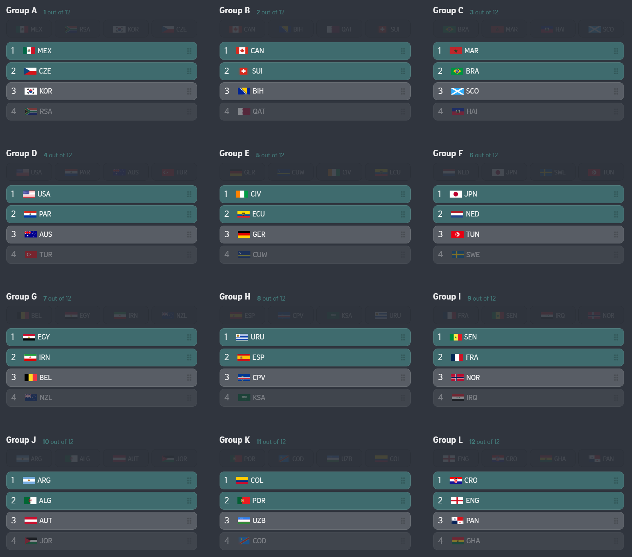
Figure 1: Predicted Group Stage Standings
Knockout Stage
This model includes ranking difference and round as features to determine knockout brackets, and has an accuracy of 49.33%. Predicted goal difference of less than -0.82 will be classified as a loss, more than -0.63 classified as a win, and a draw within 90 minutes otherwise. As matches cannot finish in a draw, a predicted goal difference of less than -0.741 will be classified as a win, and loss otherwise. As this is the first time the tournament consists of a ‘Round of 32’, such matches will be labelled under ‘Round of 16’ (Round = 2) as no historical data exists. Portugal is predicted to be the winners of the 2026 World Cup.
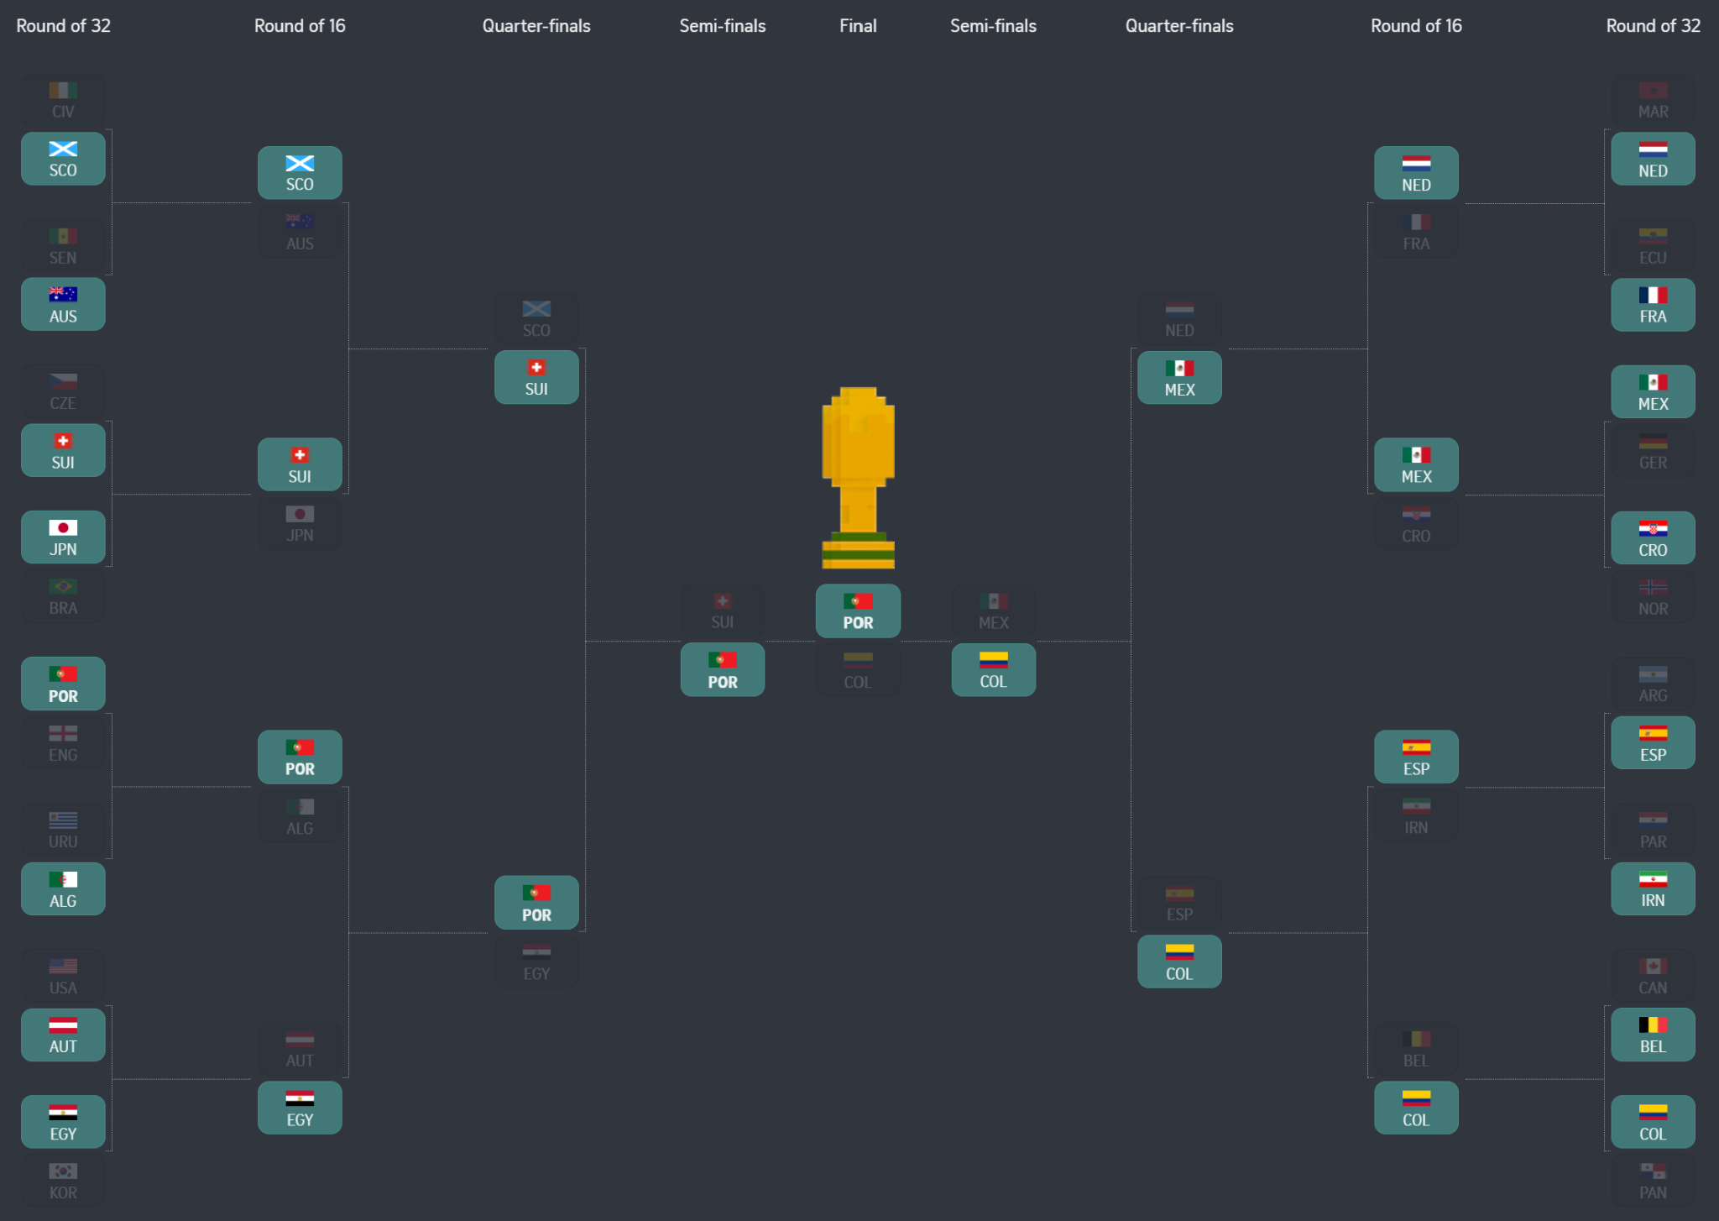
Figure 2: Predicted Knockout Bracket

If the tournament pans out as such, Roberto Martinez will be the first foreign head coach in history to lead his country to a World Cup trophy. Portugal will meet Colombia again in the Finals where they will go on to win, despite losing to them in the Group Stages.
Summary
Based on historical patterns, France are favourites to win the tournament, with Argentina eliminated by the Quarter-Finals. However, the model predicts Portugal as champions and Colombia, Mexico and Switzerland as dark horses, with Argentina eliminated in the Round of 32. I predict Netherlands to win the World Cup, with Senegal and Colombia as dark horses.

Actual Results
[Actual Results will be updated after the tournament ends]
World Cup 2026 Predictions
[Analysis will be updated after the tournament ends]

Conclusion

Petro Ivaniuk. (2023). Football - FIFA World Cup, 1930 - 2022 [Data set]. Kaggle. https://www.kaggle.com/datasets/piterfm/fifa-football-world-cup
Sara Zahran. (2025). WC2026 Match Probability Baseline Dataset [Data set]. Kaggle. https://www.kaggle.com/datasets/sarazahran1/wc2026-match-probability-baseline-dataset
The Straits Times. (2025). World Cup 2026 simulator [Interactive Graphic]. The Straits Times. https://www.straitstimes.com/multimedia/graphics/2025/12/worldcup-2026-simulator/index.html

